5. This is the graph of y = x2 – 2x – 4.

(a) Verify this from the information given in the graph. Two sums are required. (2 marks)

(b) What do you notice on the graph when y = -5? Factorise the equation and solve for x. (2 marks)

(c) How does this confirm or deny your observation in (b)? (1 mark)

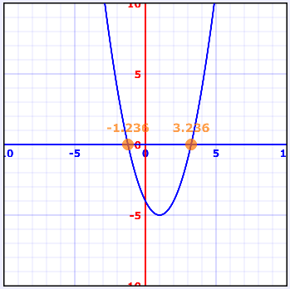

6. A pyramid, ABCDE, has a square base, ABCD, with sides of length 8 cm. Each sloping edge is 9 cm long.

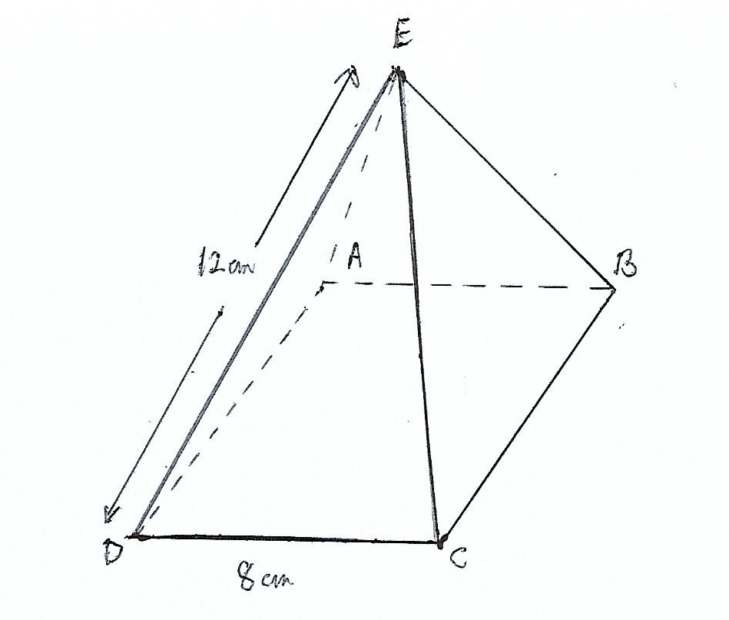

1. Calculate the height of the pyramid. (2 marks)
2. Calculate the angle the sloping edge DE makes with the base. (2 marks)

7. A,B,C and D lie on the circle, centre O. BD is a diameter and the line PAT is the tangent at A. Angle ACD = 52° and angle CDB = 33°.

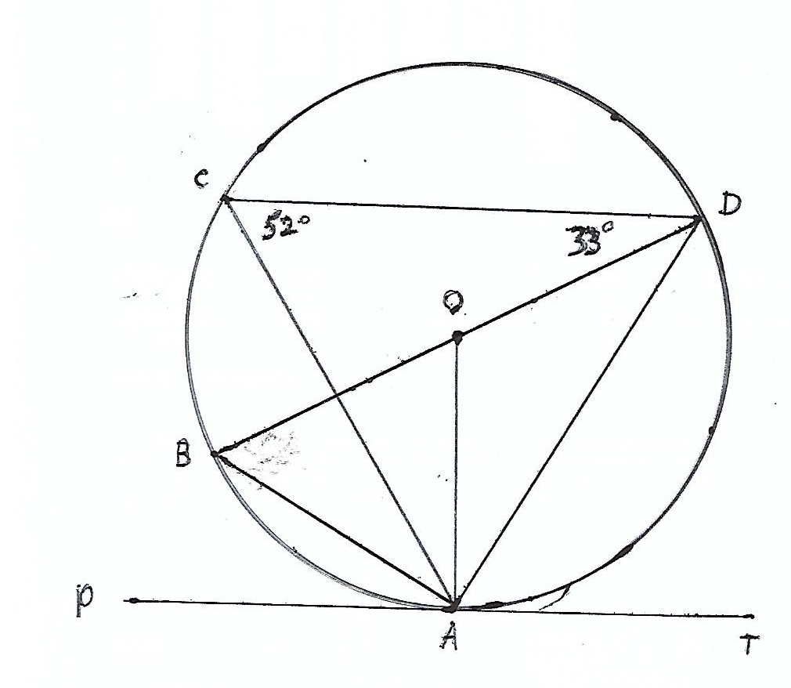

Find:

1. angle ABD
2. angle ADB
3. angle DAT
4. angle CAO

(4 marks)

8. The diagram shows a regular polygon with side 5 cm. O is the centre of the polygon.

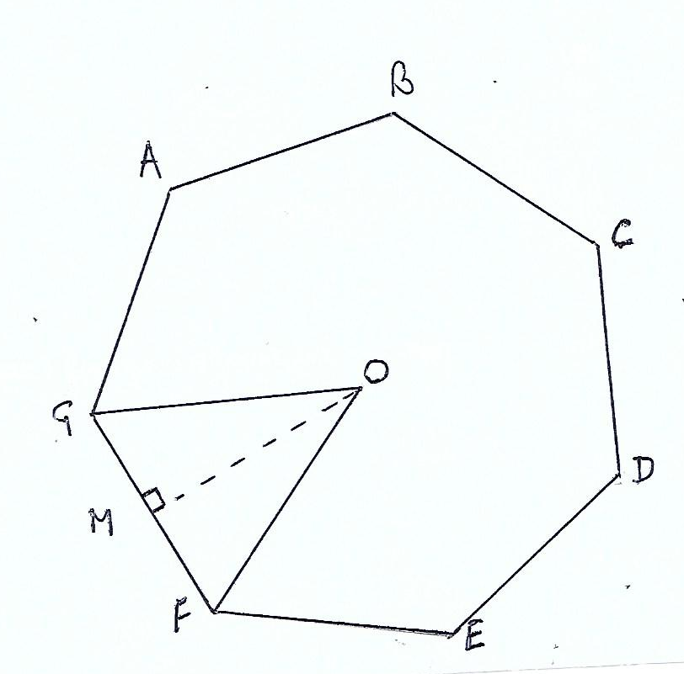

1. Find angle GOF.
2. Find angle GOM.
3. Use trigonometry on triangle GOM to find the length OM.
4. Find the area of triangle GOM.
5. Find the area of the polygon.

(4 marks)